System Specification and Design
Version 1.0

<Farzaneh Bagheri .Christoph Wenge,Cristian Beceanu>

September 2024

INTERNAL REFERENCE
Deliverable No.: | D 2.2 (2024)
Deliverable Name: | System Specification and Design
Lead Participant: | INELSO
Work Package No.: | WP2
Task No. & Name: | T 2.2 System Specification and Design
Document (File): | Dokument2 [UPDATE FIELD!]
Issue (Save) Date: | 0000-00-00 [UPDATE FIELD!]

Document status

 | Date | Person(s) | Organization
Author(s) | 2024-09-09 | Farzaneh Bagheri | INELSO Energy Company
 | 2024-08-10 | Christoph Wenge | Fraunhofer IFF
 | 2024 -08-10 | Cristian Beceanu | BEIA Consult
Verification by | 2024 -08-15 | Cristian Beceanu | BEIA Consult
Approval by
Approval by
Document sensitivity
☐x | Not Sensitive | Contains only factual or background information; contains no new or additional analysis, recommendations or policy-relevant statements
☐ | Moderately Sensitive | Contains some analysis or interpretation of results; contains no recommendations or policy-relevant statements
☐ | Sensitive | Contains analysis or interpretation of results with policy-relevance and/or recommendations or policy-relevant statements
☐ | Highly Sensitive  Confidential | Contains significant analysis or interpretation of results with major policy-relevance or implications, contains extensive recommendations or policy-relevant statements, and/or contain policy-prescriptive statements. This sensitivity requires SB decision.
☒ [copy and delete]

Table of content
1 Introduction 4
2 System Architecture 5
2.1 Block diagram 5
Digital Control Unit (DCU) Structure consists of the following parts: 5
2.2 Data flow 6
2.3 Component Specification 8
2.3.1 Hardware Specifications 8
2.3.2 Software Specifications 8
2.3.3 Communication Specifications 9
3 Framework of PV Fault Detection 9
4 Mathematical toolbox integration 10
5 System Design Consideration 11
6 Conclusions 14
7 References 14

Disclaimer
The content and views expressed in this material are those of the authors and do not necessarily reflect the views or opinions of the ERA-Net SES initiative. Any reference given does not necessarily imply the endorsement by ERA-Net SES.
About ERA-Net Smart Energy Systems
ERA-Net Smart Energy Systems (ERA-Net SES) is a transnational joint programming platform of 30 national and regional funding partners for initiating co-creation and promoting energy system innovation. The network of owners and managers of national and regional public funding programs along the innovation chain provides a sustainable and service-oriented joint programming platform to finance projects in thematic areas like Smart Power Grids, Regional and Local Energy Systems, Heating and Cooling Networks, Digital Energy and Smart Services, etc.
Co-creating with partners that help to understand the needs of relevant stakeholders, we team up with intermediaries to provide an innovation eco-system supporting consortia for research, innovation, technical development, piloting and demonstration activities. These co-operations pave the way towards implementation in real-life environments and market introduction.
Beyond that, ERA-Net SES provides a Knowledge Community, involving key demo projects and experts from all over Europe, to facilitate learning between projects and programs from the local level up to the European level.
www.eranet-smartenergysystems.eu

Introduction
The efficiency of a solar energy farm is critically dependent on the detailed analysis of parameters such as voltage, current, temperature, and irradiance for each panel. Effective monitoring of utility-scale solar arrays is essential for minimizing maintenance costs and optimizing photovoltaic (PV) performance under varying conditions. For instance, recent studies have shown that comprehensive monitoring can lead to significant improvements in operational efficacy [1].
As outlined in [2], the global growth of photovoltaic (PV) solar technology has been remarkable, with installations reaching 420 GW, effectively doubling from 2022 to 2023. This study categorizes PV systems into centralized large-scale power stations and distributed rooftop systems, pointing out the challenges they present to grid resilience, particularly during peak daylight hours. It emphasizes the necessity for diligent monitoring and accurate peak power estimation, discussing hardware-based monitoring for high accuracy versus cost-effective remote sensing techniques, thereby providing a solid basis for advancing solar PV generation and clean energy solutions.
Moreover, the importance of real-time monitoring is further highlighted in [3], which addresses the sensitivity of solar energy systems to environmental factors like irradiance, dust, and temperature. This paper conducts a comparative analysis of IoT-based solutions focusing on critical components such as computer boards, sensors, communication systems, servers, and architectural frameworks. It recommends adopting an edge computing paradigm and leveraging Amazon Web Services (AWS) for efficient, scalable monitoring. Additionally, the integration of AI techniques enhances system management and performance analysis, which is vital for optimizing solar energy utilization.
Building on these insights, [4] proposes an online smart monitoring solution for PV power plants aimed at enhancing fault diagnosis and reducing maintenance costs. This system can identify malfunctions caused by both accidental factors, such as dirt accumulation and shading, and technical faults in the modules. By analyzing I-V and P-V curves in real-time and comparing them to theoretical models, the system effectively operates without interrupting energy generation, with field tests confirming its effectiveness for predictive maintenance applications.
In the context of real-time monitoring, [5] introduces an IoT-based remote monitoring and control system that incorporates AI for improved automation. This framework is structured in four layers: IoT hardware, communication, cloud infrastructure, and data analytics. It aims to provide proactive measures and real-time automation to enhance the productivity of renewable energy systems. Key areas of value identified include fault prediction, service life estimation, and AI-enabled optimization.
Furthermore, [6] describes an Intelligent Monitoring System (IMS) for PV systems that utilizes affordable hardware and lightweight software for easy implementation across various PV plants. It employs IoT for data management and features a personal cloud server for data storage. While this approach offers deep learning models for fault detection and power prediction, concerns about data security and privacy associated with cloud storage remain significant challenges.
Lastly, [7] introduces a unified health-state architecture designed to diagnose and predict failures in PV systems. This architecture utilizes data quality routines, digital twin models, and AI-driven diagnostic algorithms, validated using diverse historical data. However, its reliance on extensive historical data may limit its application in regions with fewer data records, and the complexity of implementing digital twin models could pose challenges for smaller PV operations.
In alignment with these studies, Work Package 2 (WP2) of the ZERODEFECT4PV project lays the groundwork for a comprehensive solar panel monitoring and predictive maintenance system. WP2 related to T2.2 focuses on system specification and design, creating a blueprint that integrates various components, including Data Collection Units (DCUs), communication protocols, and data flow mechanisms into a cohesive framework. The goal is to develop an infrastructure that supports panel-level monitoring and accurate data collection, addressing the shortcomings of traditional string-based monitoring systems.
WP2 aims to establish a robust, scalable architecture employing individual DCUs on each panel or small cluster, with data routed through a mesh network to ensure reliable communication with the Energy Operations Center (EOC). This innovative approach not only enhances monitoring accuracy but also facilitates continuous data flow for proactive maintenance, ultimately supporting the broader goals of improving the efficiency and reliability of solar energy systems. By bridging the insights gathered from the literature with the practical framework provided by WP2, this report outlines a comprehensive strategy for advancing solar energy monitoring and performance optimization.

2 System Architecture
The system employs a decentralized architecture where Data Collection Units (DCUs) are deployed on individual solar panels or clusters. These DCUs collect data and communicate via a mesh network, relaying information to the Energy Operations Center (EOC) where it is processed and analyzed.

Block diagram
Digital Control Unit (DCU) Structure consists of the following parts:
- Sensors: These are components integrated into the DCU and responsible for collecting data such as temperature, voltage, current, and other performance indicators from individual solar panels.
- Slave Units:
  - The slave units in the master-slave architecture would be the individual DCUs attached to each solar panel (or small cluster of panels). These DCUs, with their integrated sensors, collect real-time data from the panels.
  - Each slave DCU collects sensor data and relays it to the master unit.
- Master Units:
  - The master unit is responsible for aggregating data from multiple slave units (DCUs) and managing communication between the DCUs and the Energy Operations Center (EOC).
  - It coordinates, ensuring that all panel data is efficiently transmitted to the central monitoring system (EOC) and other analytic components.
- Energy operation Center:
  - Centralized Data Collection and Integration
  - Real-Time Monitoring
  - Predictive Maintenance and Fault Detection
  - Decision-Making and Optimization
  - Control and Automation
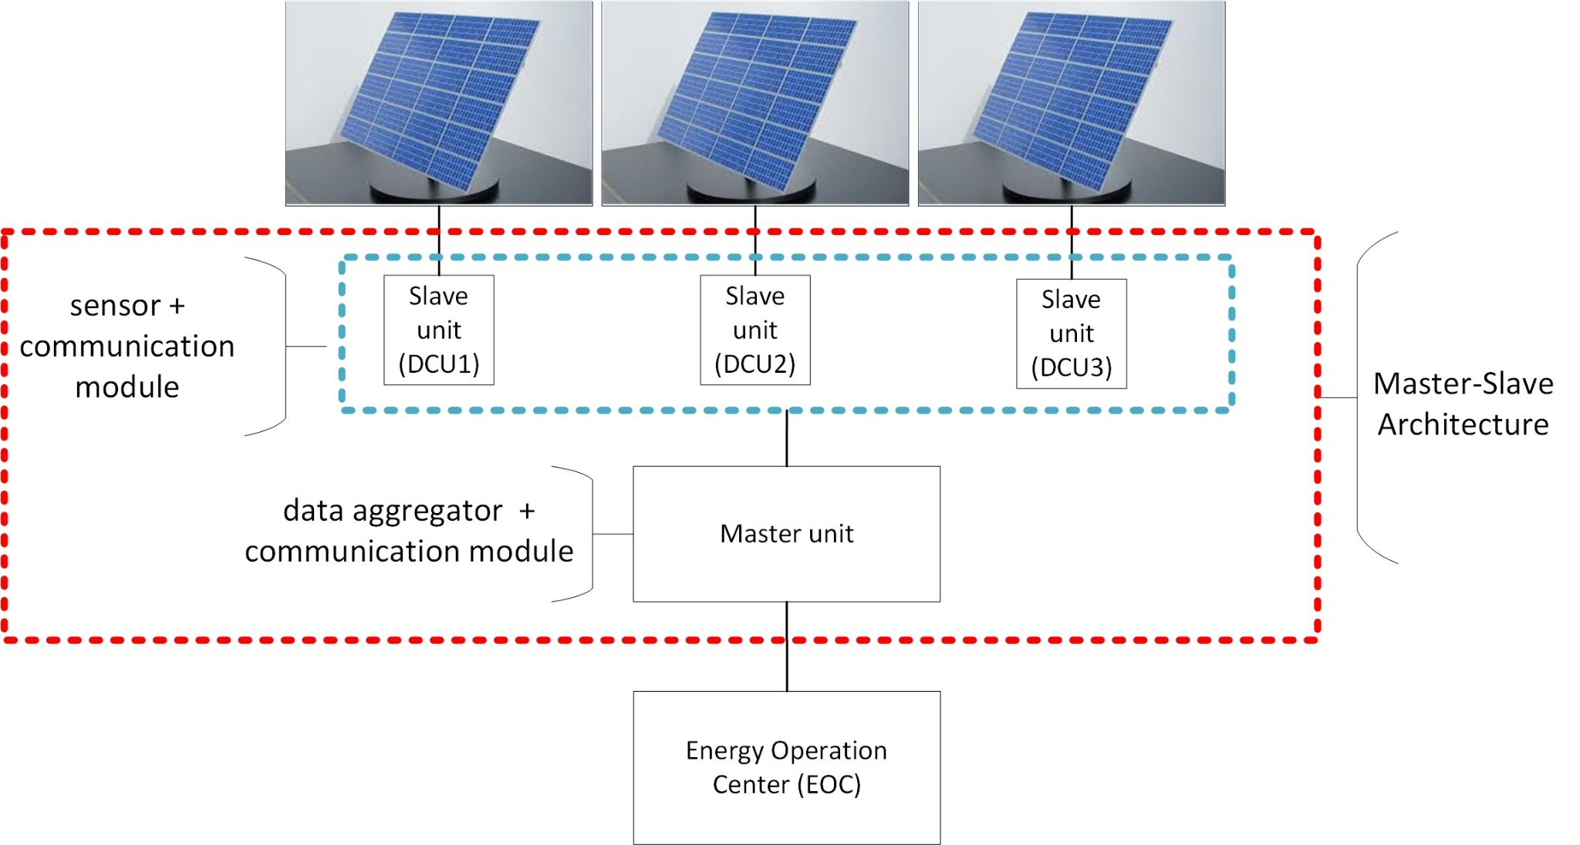
Fig 1: Block diagram of the system architecture

2.2 Data flow
In the ZERODEFECT4PV system, the data flow is structured to provide real-time, reliable, and scalable monitoring of solar panels at the individual level. The flow begins with Data Collection Units (DCUs), each acting as a node within a distributed mesh network. The primary role of the DCUs is to gather essential performance metrics such as voltage, current, temperature, and other relevant indicators from the solar panels they are attached to. By focusing on panel-level monitoring, the system ensures that even the smallest defects or inefficiencies are detected early, enhancing the precision and effectiveness of maintenance efforts.

1.Transmission Through the Mesh Network
Once the DCUs collect the necessary data, the information is transmitted through a self-healing mesh network. In this architecture, every DCU acts as both a data generator and a transmission node, meaning it can forward data collected from nearby panels to the next available node. This structure ensures that data can be transmitted to the central Energy Operations Center (EOC) even if individual nodes (DCUs) experience communication failures. The network dynamically routes the data through alternative nodes, thus maintaining the integrity and continuity of the data flow. This mesh architecture provides a high level of redundancy and resilience, making it ideal for large-scale solar farms where network stability is paramount.
For example, in a solar farm with 100 panels, if one DCU loses connection with the master unit or the EOC, the mesh network can find another route through neighboring DCUs to ensure that the data still reaches its destination. This feature significantly reduces the risk of data loss or system downtime, even in cases where individual DCUs experience technical difficulties. Furthermore, as the system grows with the addition of more panels and DCUs, the mesh network naturally expands, adjusting to the increased load and ensuring continuous monitoring without manual intervention.
2.Data Handling at the Energy Operations Center (EOC)
When the data reaches the EOC, it is processed through the integrated mathematical toolbox. This toolbox performs a variety of essential functions, starting with data cleaning, which filters out inconsistencies and removes noise to ensure the accuracy and reliability of the data. Once cleaned, the data is analyzed for any signs of anomalies using advanced machine learning algorithms such as Random Forest (RF), Artificial Neural Networks (ANN), and Support Vector Machines (SVM). These algorithms are designed to identify unusual patterns or deviations from normal operation, which could indicate a potential fault in a solar panel.
Additionally, the system’s predictive modeling capabilities enable operators to foresee potential issues before they escalate into critical failures. By comparing real-time data with historical performance metrics, the system can predict which panels are most at risk of failure, allowing maintenance teams to take proactive action, thus minimizing downtime and maximizing energy production.
3.Data Storage and Accessibility
Once the data has been processed, it is stored in a secure, high-redundancy database at the EOC. This storage ensures that all performance data, both current and historical, is readily accessible for long-term analysis, reporting, and compliance purposes. The processed data is then made available to solar plant operators through a user-friendly dashboard that provides real-time insights into panel performance, fault predictions, and key performance indicators (KPIs).
The dashboard is designed to offer operators visual representations of the solar plant’s status, including energy output, potential faults, and the overall health of the system. This enables them to make informed, data-driven decisions to optimize the plant's operation and performance. By leveraging this intuitive interface, operators can quickly assess the plant's efficiency, identify underperforming panels, and take action to resolve issues before they affect the entire system.
4.Dynamic Adaptability and Scalability
One of the most valuable aspects of the mesh network in this data flow is its ability to dynamically adjust to changes within the solar installation. For instance, if new DCUs are added to accommodate additional solar panels, the network automatically integrates the new units, enhancing both the coverage and performance of the system. The mesh network scales horizontally, meaning the addition of new nodes improves overall network resilience and efficiency, allowing the system to handle larger and more complex solar installations without significant manual reconfiguration.
Furthermore, in cases where environmental factors or system setup change—such as fluctuating temperatures or shading caused by cloud cover—the system can quickly adapt. The self-healing nature of the network ensures that data routing is optimized based on the real-time conditions of the solar plant, maintaining a steady flow of information to the EOC without disruptions.
5.Resilience and Redundancy
The mesh network’s resilience is a key feature that ensures continuous data flow even in challenging scenarios. For example, if a particular DCU experiences a failure—whether due to a faulty sensor or a communication issue—the network reroutes the data through neighboring DCUs, ensuring no loss of information and maintaining consistent panel monitoring. This redundancy significantly increases the overall reliability of the system, allowing operators to trust that even with occasional hardware issues, the monitoring system will continue to function effectively.
In summary, the data flow in the ZERODEFECT4PV system is designed to be robust, efficient, and scalable, with a focus on ensuring real-time, uninterrupted monitoring of solar panels. The combination of panel-level data collection, mesh network communication, and advanced data processing at the EOC guarantees that solar plant operators receive the insights they need to maintain optimal system performance, detect faults early, and perform predictive maintenance to avoid potential failures.

2.3 Component Specification

2.3.1 Hardware Specifications
- DCUs:
  - Processor: Low-power microcontrollers (e.g., ARM Cortex M-series) for efficient data processing.
  - Sensors: High-precision sensors for monitoring voltage, current, and temperature on each solar panel.
  - Memory: Non-volatile memory for temporary data storage in case of network disruptions.
  - Communication Module: LoRa, Zigbee, or Wi-Fi module for mesh network communication.
  - Power Supply: Solar-powered with battery backup for uninterrupted operation.
- EOC Hardware:
  - Servers: High-performance servers (either on-premise or cloud) capable of processing large data streams.
  - Database: High-redundancy databases (e.g., SQL, NoSQL) for storing panel-level data and historical performance logs.
  - Dashboard Interface: Workstations with real-time monitoring dashboards for plant operators.

2.3.2 Software Specifications
- DCU Software:
  - Firmware: Lightweight, real-time software on the slave DCUs for sensor data collection and transfer.
  - Master Unit Software: Aggregation algorithms on the master units to process and relay data to the EOC efficiently.
  - MQTT Protocol: A lightweight messaging protocol (MQTT) will be used to ensure fast and secure data communication between DCUs and the EOC.
- EOC Software:
  - Data Processing Engine: Real-time analytics engine that processes incoming data from the master DCUs and generates actionable insights.
  - AI Algorithms: Machine learning models for predictive maintenance, which analyze historical and real-time data to detect potential faults or performance issues.
  - Dashboard: A user-friendly interface to provide operators with panel-level insights, alerts, and performance reports.

2.3.3 Communication Specifications
- Mesh Network: The DCUs communicate with each other using a self-healing, multi-hop mesh network to ensure data is transmitted across nodes efficiently.
- Protocol: The MQTT protocol will facilitate communication, enabling efficient message delivery even in low-bandwidth conditions

3 Framework of PV Fault Detection
The Framework for PV Fault detection illustrated in figure 1 for the German demonstrator outlines the metering network, laboratory network, and DMZ, which outline the photovoltaic system with the data acquisition from them, application, and data server together with the MQTTs gateway.
The EOC or Integrated Operation Center (IOC) is a central facility for researching and testing innovative control algorithms and strategies in smart grids. It optimizes coordination, data management, and communication for automated control tasks and disruption responses. Using digital twins and machine learning, the IOC enhances network monitoring reliability and optimizes energy facility planning. It manages the Elbfabrik complex and integrates infrastructures like energy supply and ICT. The IOC improves operational efficiency, detects bottlenecks early, promotes sustainability, and offers advanced forecasting and diagnostic functions.
The system comprises two rooftop photovoltaic (PV) systems: a 9.51 kWp system incorporating three distinct types of PV modules located on the existing section of the "Elbfabrik," and a 34.68 kWp system utilizing a singular type of PV module in the newly constructed section. PV parameters are monitored through Kostal and SMA inverters, with data acquisition from the Kostal inverter facilitated by Solarlog and from the SMA inverter through the Sunny Data Manager SDM).
The data collected are integrated into the Integrated Operations Center (IOC) laboratory network to enhance forecasting and diagnostic capabilities, employing artificial intelligence algorithms for diagnosing PV faults.
The Data Management Zone (DMZ) serves as a controlled environment for the aggregation, processing, and analysis of data collected from Data Collection Units (DCUs) deployed on solar panels or clusters. The DMZ facilitates secure and efficient data flow between the decentralized architecture of the solar systems and the Energy Operations Center (EOC) or Integrated Operations Center ((IOC). It enhances data integrity and ensures that the information relayed to the IOC for further analysis is accurate and reliable. This structured approach allows for improved coordination, data management, and communication, ultimately supporting the optimization of control algorithms, fault diagnosis, and overall operational efficiency in smart grid applications."
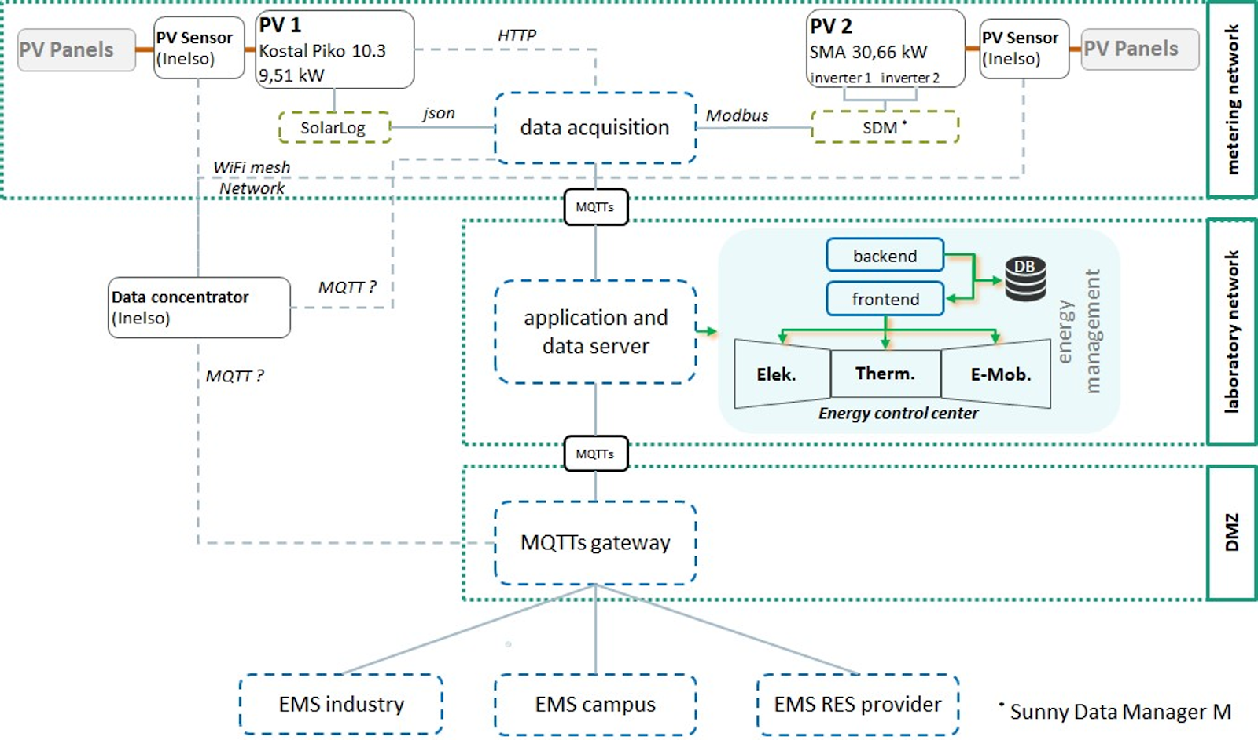
Fig 2: System architecture illustrating the integration concept of the German demonstrator within the Integrated Operations Center IOC)

The Romanian demonstrator of BEIA Consult will validate the solution of the PV fault detection system after the initial sensor testing from INELSO. The photovoltaic system of BEIA comprises one rooftop photovoltaic (PV) system with a 6 kW system incorporating 20 PV modules with a surface of 20m2 .PV parameters are monitored through the SolarEdge inverter. Power optimizers track the MPPT (maximum power point tracking) of the panels and control the DC-DC conversion of each panel together with the inverter.

4 Mathematical toolbox integration
The mathematical toolbox will have functions such as:
- Data Cleaning: Automated tools to correct inconsistencies and filter out noise.
- Anomaly Detection: Algorithms that identify unusual patterns in the data, indicating potential faults.
- Predictive Modeling: Machine learning models that forecast future performance and identify panels at risk of failure.
The mathematical toolbox is integrated into the EOC’s software stack, interfacing directly with the data collected by the DCUs. The toolbox processes this data in real time, providing operators with insights and predictions that are visualized on the EOC dashboards.
The most promising AI algorithms for PV fault diagnosis include Random Forest (RF), Artificial Neural Networks (ANN), k-Nearest Neighbors (kNN), and Support Vector Machines (SVM). The selection and evaluation of these AI methods were based on an extensive literature review of diagnosable PV faults related to existing PV parameters and the employed AI algorithms.
The primary objective is to evaluate the collected data to detect, classify, and localize PV errors. To achieve this, it is essential to pre-process the collected PV parameters to eliminate noise, normalize data from consortium partner PV plants, and perform plausibility checks. Detected faults will be categorized based on severity as either temporary or permanent, negligible or remedial. The results will assist plant operators through actions and assistance functions, information messages, reporting, alarms, and autonomous functionalities.
Additionally, assistant functions based on predefined key performance indicators will inform the operator about the reliability and durability of the PV system, as well as yield losses caused by economic factors, energy efficiency, and the frequency of occurrences.

5 System Design Consideration
When designing the ZERODEFECT4PV monitoring system, several critical factors need to be addressed to ensure that the system operates efficiently, reliably, and securely. These factors include the scalability of the network, the security of data transmissions, and the overall integrity of the communication infrastructure. Below are the key considerations that were taken into account during the system design:

1.Scalability and Flexibility
The system is designed to be highly scalable, which allows for the seamless integration of additional Data Collection Units (DCUs) and solar panels without interrupting or disrupting the existing operations of the solar plant. Scalability is crucial for large solar installations that continuously expand over time. By leveraging a horizontal scaling model, the system can incorporate more nodes (DCUs) as new panels are added to the solar farm.
- Horizontal Scaling: Horizontal scaling allows the system to increase capacity by adding new DCUs to monitor more solar panels. This is done without compromising the performance of the monitoring network, as each new DCU enhances the system's coverage and data-gathering capabilities.
- Mesh Network Adaptability: The use of a self-healing mesh network supports the scalability of the system. As new DCUs are deployed, they are automatically integrated into the mesh network, enabling them to communicate with other DCUs and the Energy Operations Center (EOC). This decentralized architecture ensures that the network can adjust dynamically to accommodate more nodes, enhancing both coverage and reliability as the solar plant grows.
The mesh network also offers flexibility in terms of environmental adjustments. If new panels are installed or the geographical configuration of the solar farm changes, the network can recalibrate itself to maintain optimized data routing. This dynamic adaptability allows the system to maintain data integrity even as the plant’s physical layout or operational scope evolves.
2.Security
Given the critical nature of the data being collected and analyzed, security is a top priority in the design of the system. The system ensures that all data transmitted between the DCUs and the EOC is protected through various security mechanisms:
- Data Encryption: To safeguard the data from potential interception or tampering, all transmissions within the network are encrypted using advanced encryption protocols. This ensures that sensitive performance metrics and fault data collected from the solar panels are securely transmitted to the EOC without the risk of unauthorized access.
- User Authentication: To further enhance system security, a multi-factor authentication (MFA) system is implemented for all personnel accessing the EOC and its associated databases. MFA requires users to provide two or more verification factors—such as a password and a one-time code sent to their mobile device—to access the system. This ensures that only authorized individuals can interact with the network, preventing unauthorized access and mitigating the risk of data breaches.
- Role-Based Access Control (RBAC): Another layer of security involves role-based access control, which restricts system access based on the user's role within the organization. For instance, operators monitoring the system may have different access privileges compared to system administrators, ensuring that only relevant personnel can perform specific actions within the network. This fine-grained control reduces the likelihood of unauthorized actions that could compromise the system's integrity.
3.Network Security and Integrity
The integrity of the communication network is paramount to ensuring the system functions effectively. The design incorporates several measures to maintain the network’s security and protect it from both internal and external threats:
- Regular Security Audits: The system undergoes routine security audits to identify and address potential vulnerabilities. These audits assess the system’s infrastructure, encryption protocols, and access control mechanisms to ensure they are up to date with current security standards. Any identified weaknesses are promptly addressed through patches or system upgrades.
- Security Patches and Updates: To ensure the network remains resilient to emerging cyber threats, regular security patches are applied to both the hardware (DCUs) and software components. This includes updating the firmware on the DCUs, as well as implementing updates to the system’s communication protocols and encryption methods.
- Intrusion Detection Systems (IDS): In addition to security audits, an Intrusion Detection System (IDS) is integrated into the network to monitor real-time traffic for suspicious activity. The IDS continuously analyzes data flows between DCUs and the EOC, identifying potential intrusions or anomalies that could signify a security breach. In the event of unusual activity, the system automatically triggers alerts, allowing operators to take prompt action to mitigate any threats.
4.Data Integrity and Redundancy
In any monitoring system, ensuring data integrity is essential to producing accurate and actionable insights. The design of the ZERODEFECT4PV system includes mechanisms to guarantee that the data collected from the DCUs remains consistent and reliable throughout its journey from the panels to the EOC.
- Data Redundancy: The system employs data redundancy strategies to prevent data loss during transmission. For instance, each DCU temporarily stores the collected data locally until it has been successfully transmitted to the EOC. In the event of a network disruption or delay, the DCU can retransmit the stored data once the connection is restored, ensuring that no information is lost.
- Integrity Checks: Once the data reaches the EOC, it undergoes various integrity checks to ensure that the transmitted data is accurate and free from corruption. These checks compare the transmitted data against pre-determined benchmarks or patterns to identify any discrepancies or anomalies that may have occurred during transmission.

5.Resilience and Fault Tolerance
The design also incorporates fault-tolerant mechanisms to ensure that the system remains operational even in the event of hardware or software failures:
- Self-Healing Mesh Network: As mentioned earlier, the self-healing capabilities of the mesh network ensure that if one DCU fails, data is rerouted through other available nodes. This redundancy guarantees that the data flow is not interrupted, even if multiple DCUs experience issues. The network dynamically adjusts to maintain a stable communication pathway, ensuring minimal data loss.
- Backup Power for DCUs: Each DCU is equipped with a solar-powered battery backup, which allows it to continue operating even during temporary power outages. This ensures that data collection remains uninterrupted, and the system can maintain its monitoring capabilities under adverse conditions.

6 Conclusions
Work Package 2 (WP2) of the ZERODEFECT4PV project successfully lays the foundational groundwork for the system’s architecture, specification, and design, addressing key challenges faced by conventional solar monitoring systems. Through the detailed specification of Data Collection Units (DCUs), mesh network communication protocols, and the integration of advanced analytics, WP2 delivers a comprehensive framework for panel-level monitoring and predictive maintenance in solar power plants.
The work package ensures that the system is scalable, enabling the seamless addition of new panels and DCUs as solar plants expand, while maintaining uninterrupted operations. Furthermore, the use of a self-healing mesh network enhances the system's resilience, ensuring continuous data transmission even in the event of individual node failures. The integration of secure communication protocols, including data encryption and multi-factor authentication, ensures that all transmitted data remains protected and that only authorized personnel can access the system.
By addressing both the technical and security aspects of the system, WP2 contributes significantly to the overall objectives of the ZERODEFECT4PV project. The robust design considerations for scalability, network security, and data integrity ensure that the system is both flexible and reliable, capable of adapting to the evolving needs of solar power plants.
Ultimately, this work package sets the stage for the successful deployment of ZERODEFECT4PV, enabling more accurate fault detection, performance monitoring, and predictive maintenance. The design specified in WP2 supports the project’s goal of optimizing solar plant efficiency, ensuring that the innovative monitoring system can be implemented effectively to enhance both operational performance and energy output.

7 References
[1]Rao, Sunil, et al. Machine learning for solar array monitoring, optimization, and control. Springer Nature, 2022.
[2] SHANG, Yongheng, et al. Methods for Monitoring the Photovoltaic Panel: A Review. In: 2024 12th International Conference on Agro-Geoinformatics (Agro-Geoinformatics). IEEE, 2024. p. 1-5.
[3 ]Ali, Mohammad Imran, et al. "Harnessing the Cloud: A Novel Approach to Smart Solar Plant Monitoring." Future Internet 16.6 (2024): 191.
[4] FELIPE, Thiago A.; MELO, Fernando C.; FREITAS, Luiz CG. Design and Development of an Online Smart Monitoring and Diagnosis System for Photovoltaic Distributed Generation. Energies, 2021, 14.24: 8552.
[5] MALIK, Azra; HAQUE, Ahteshamul; KURUKURU, VS Bharath. IoT‐Based Monitoring and Management for Photovoltaic System. Fault Analysis and its Impact on Grid‐connected Photovoltaic Systems Performance, 2022, 291-318.
[6] EMAMIAN, Masoud, et al. Cloud computing and IoT based intelligent monitoring system for photovoltaic plants using machine learning techniques. Energies, 2022, 15.9: 3014.
[7] MONTES-ROMERO, Jesus, et al. Novel data-driven health-state architecture for photovoltaic system failure diagnosis. Solar Energy, 2024, 279: 112820.

funding

This document was created as part of the ERA-Net Smart Energy Systems project ZERODEFECT4PV, funded from the European Union’s Horizon 2020 research and innovation programme under grant agreement no. 646039 (SG+) / no. 775970 (RegSys) / no. 883973 (EnerDigit).

